Use Case Diagram

Football Club Management

Group-20

Kazi Ehsanul Mubin

ID-18101391

Umma Tania Arafin

ID- 18201203

CSE471 Lab Project

Section 02

Use Case Diagram

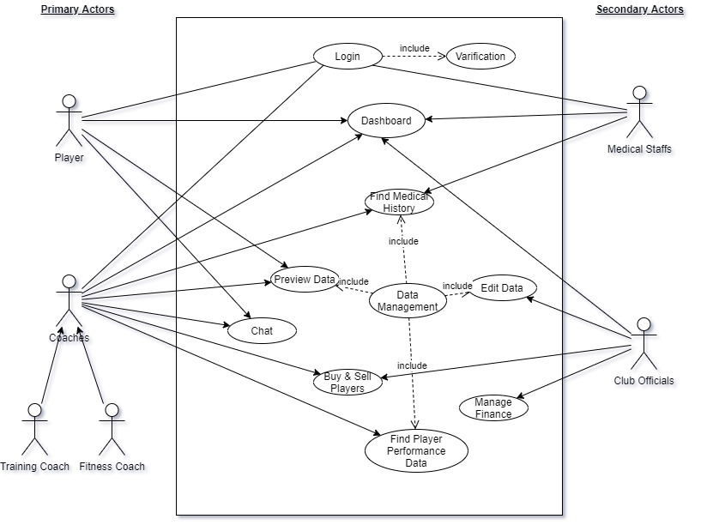

Description-

The Use Case Diagram of Football Club Management System has four Actors. Players and Coaches are Primary Actors where Coaches has two child-actors. And Club Official and Medical Staff’s are secondary actors. They do not directly influence the system. But they react to the primary actors. All actors can login to the system, where first login requires mandatory verification. This system is all about data. So, the actors mainly play role in data managements like the user case showed. For example, Coaches can analyze data to find players suitable for optimal roles. Medical staffs can check medical history for the players. Players and coaches can preview data. But only staffs can edit data. And Managing stuffs can manage club finance, wages and bonuses. There is also a chatting platform for players and coaches to communicate between each other. There are also a dashboard where coaches informs the teams about next fixtures, injured players, training routine or selected XI for an upcoming match.

Shareable Link for UML Diagram File-

https://drive.google.com/file/d/1SkGEcARro1U1A7sGMGEKO_VtIDRjOzwI/view?usp=sharing